Workers’ Compensation Reference Guide
Risk Management and Benefits Department

Updated for Fiscal Year 2019
2019-2020 School Year

Section I - Introduction
Contact Information………………………………………………………………………………………………………………………………..3
Florida Statute…………………………………………………………………………………………………………………………………………4
Drug & Alcohol-Free Workplace (S.B. Policy 3124)…………………………………………………………………………………..4
Post-Accident and Reasonable Suspicion Drug Testing…………………………………………………………………………….5

Section II – How to Report an Injury/Illness
First Report of Injury (Johns Eastern Instructions)……………………………………………………………………………….….6
After Hours Reporting……………………………………………………………………………………………………………………………15
Pharmacy Information…………………………………………………………………………………………………………………………..16
Bloodborne Pathogen Exposure Reporting…………………………………………………………………………………………….17
Authorized Initial Care Facilities…………………………………………………………………………………………………………….18
Emergency Room…………………………………………………………………………………………………………………………………..19

Section III – Workers’ Compensation Guidelines
Employees with Work Restrictions (Light Duty)……………………………………………………………………………………..20
Workers’ Compensation Leave………………………………………………………………………………………………………………21
Payroll Coding……………………………………………………………………………………………………………………………………….21
Workers’ Compensation Doctors Appointments……………………………………………………………………………………22

Section IV – Substitutes and Volunteers
Reporting Volunteer/Temporary Employee Injuries………………………………………………………………………………23

Section V – Forms
Resources/Sample Forms………………………………………………………………………………………………………………………24
Frequently Asked Questions………………………………………………………………………………………………………………….25
Best Practices………………………………………………………………………………………………………………………………………..26

- Modified Duty Assignments  - Questions on work restrictions  - Determination for coding line of duty | Maria Lugo  Workers Compensation Technician  maria.macedo@polk-fl.net  Michael Bellows  Analyst – Risk Management  michael.bellows@polk-fl.net | 863-519-3858 ext:473  863-519-3858 ext:582  Fax: 863-519-3740
Third Party Claims Administrators  - Assistance with questions  regarding claims | Johns Eastern  PO Box 110279  Lakewood Ranch FL 34211  Adjusters:  Tracie Jones  tjones@JohnsEastern.com,  Cathy Gist  cgist@JohnsEastern.com | 1-800-749-3044  Fax:813-402-7922  863-519-3858 ext.: 481
Section I: Introduction
Polk County Public Schools Risk Management
Workers’ Compensation Contact Information

Florida State Statute 440.015 Legislative Intent:
It is the intent of the Legislature that the Workers’ Compensation Law assures the quick and efficient delivery of disability and medical benefits to an injured worker and facilitates the worker’s return to gainful re-employment at a reasonable cost to the employer.

Polk County Public Schools Risk Management and Employee Benefits Department:
An effective workers’ compensation program begins before an accident occurs. There are many players in the workers’ compensation system concerned with the delivery of benefits to the injured worker: District Risk Management staff, Johns Eastern Group adjusters, physicians, and most importantly you, the employees. Without the employee’s hard work, dedication, and involvement, the workers’ compensation system will not work.
If a school district employee experiences an unexpected or unusual injury or an accident in the workplace resulting in personal injury, it is our intent to make sure that the injured worker receives the best care available.

Drug-Free Workplace:
Polk County Public Schools hereby affirms its commitment to maintaining a drug-free workplace. The term “drug-free” includes “alcohol-free”.
School Board Policy 3124: The School Board recognizes that substance abuse in our nation and our community exacts staggering costs in both human and economic terms. Substance abuse causes impaired job performance, lost productivity, absenteeism, accidents, wasted materials, lowered morale, higher health care costs, and diminished interpersonal relationship skills. The Board commits to creating and maintaining a drug-free workplace.
The use of illegal drugs, the abuse of alcohol, and the misuse of prescription and over-the-counter drugs are unacceptable.
It is a standard of conduct for employees and a condition of employment with the Board that employees shall not use illegal drugs and shall not abuse alcohol. In order to maintain this standard, the Board shall establish and maintain the programs, rules, and drug/alcohol testing program set forth in the Board's Drug-Free Workplace Program rules.
The use, sale, purchase, possession, manufacture, distribution, or dispensation of controlled substances (illegal drugs) on Board property is against the law and Board policy and is cause for immediate discharge.
Any employee determined to be in violation of this policy is subject to disciplinary action, which may include termination, even for the first offense.

The Board will provide the employees with substance abuse education programs which will help employees to identify personal and emotional problems which may result in the misuse of alcohol and/or other drugs and the legal, social, physical, and emotional consequences of the misuse of alcohol and other drugs. The Board maintains an Employee Assistance Program (EAP), which provides employees with professional counseling for, but not limited to, substance abuse problems. The EAP is designed to be an employee resource for overcoming personal problems which affect work performance. (Policy 3170.01 - Employee Assistance Program (EAP))
Substance abuse testing will be conducted for all final job candidates. Immediate re-testing shall be performed for prospective employees who fail the initial drug screening. Drug testing will also be conducted for active employees in the following instances:
A. reasonable cause to believe an employee is involved in substance abuse;
B. on-the-job injury;
C. upon return to duty from a substance abuse rehabilitation program;
D. as a part of a consistently scheduled physical examination; or
E. as a part of a random selection process for employees in predetermined departments and/or high-risk positions.

Any employee in violation of this policy shall be immediately suspended by the Superintendent and shall be subject to appropriate disciplinary action up to, and including, termination.
In lieu of termination, the Superintendent may refer the employee to a substance abuse rehabilitation program structured and monitored closely by the Board Employee Assistance Provider (EAP). Employees who successfully complete a rehabilitation program may return to duty upon the written recommendation of the EAP or their Substance Abuse Rehabilitation Treatment provider.
Failure by any employee of this Board to report a known violation of the foregoing drug-free workplace policy would constitute an act of insubordination and willful neglect of duty.
For the purposes of this policy the following definitions will apply:
"Controlled substance" or "substance" means a controlled substance as defined by 41U.S.C. 706 or as defined by F.S. 893.02.
"Drug-free workplace" means any property, building, facility, site, location, or place wherein employees engage in school-related activities or otherwise act within the scope of their employment.

Drug Testing:
Pursuant to recent statutory amendments, all employees receiving treatment through the District’s Workers’ Compensation program are subject to substance abuse testing by participating providers. Results that do not comply with the District’s drug-free workplace policies will be forwarded to the PCPS Human Resource department for further review and disposition.

Section II: How to Report an Injury or an Illness
First Report of Injury – Johns Eastern Instructions
Accessing First Report of Injury Entry System:
- Go to: https://johnseasternenterprise.jw-filehandler.com/Login.aspx
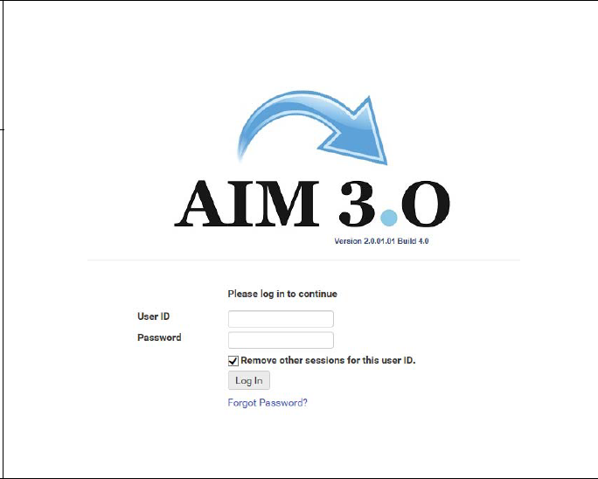
- Log in with the supplied username and password. At first login, your password will be PCS1234 (Note PCS is capital. After your initial log-in, you will be prompted to create your own password. If the system indicates that your account is locked, select the option to reset your password.

*Principal’s secretaries must contact Risk Management to request access to the Johns Eastern System.

To add a new FROI Entry:

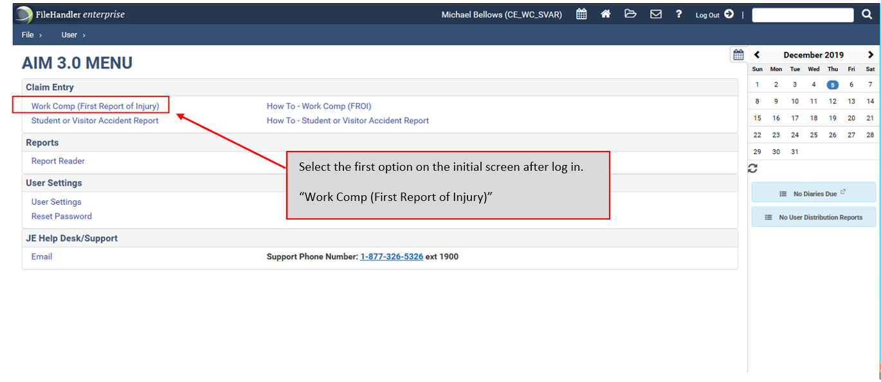
- Select the first option on the initial screen after log in, “Work Comp (First Report of Injury)”.

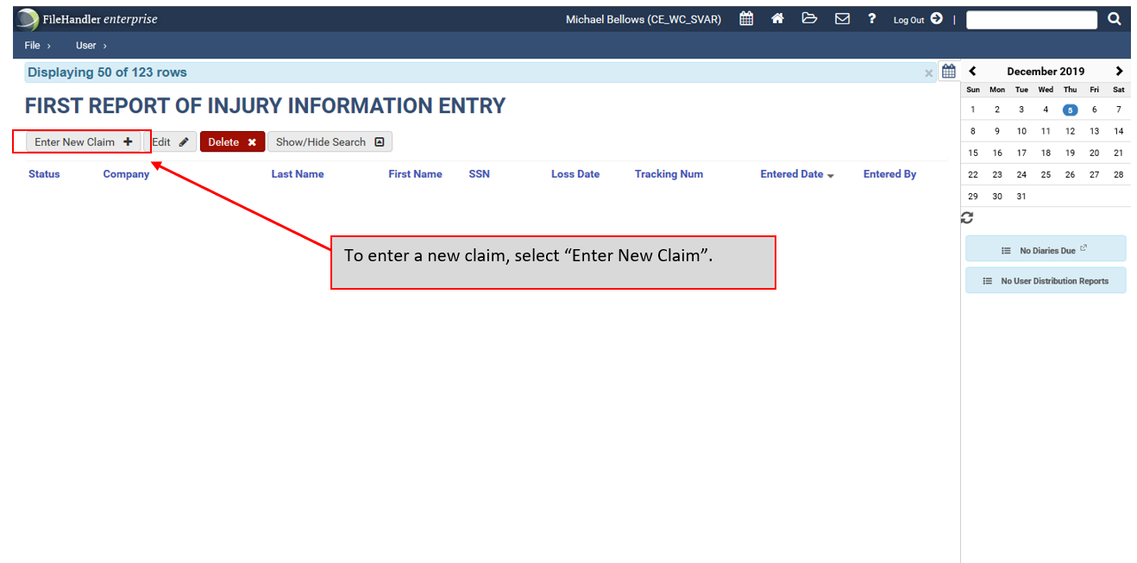
- To enter a new claim, select “Enter New Claim +”.

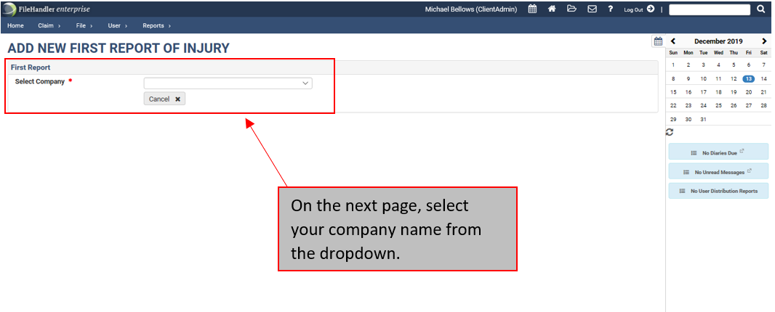
- You will be prompted to select your company from a dropdown menu. Select “Polk County School Board”.

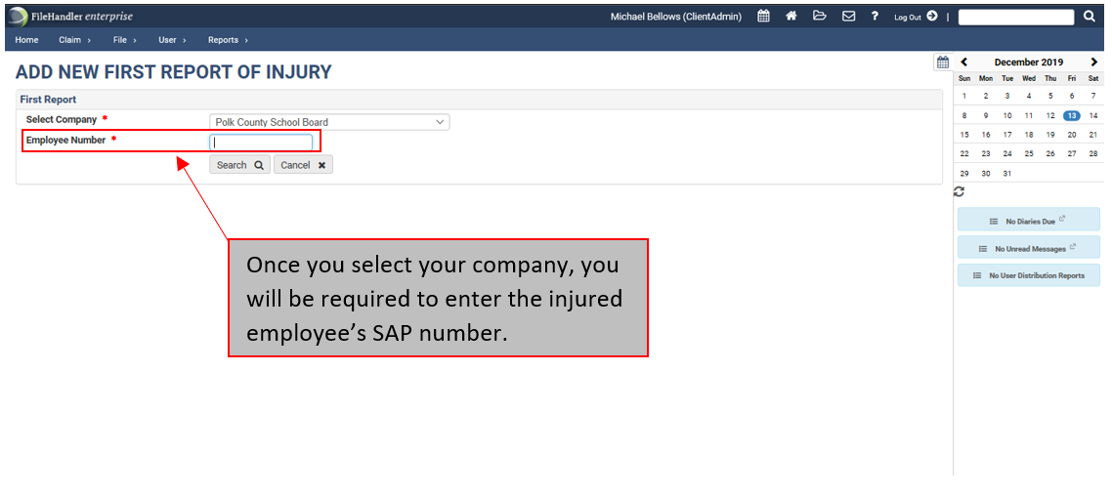
- Once you have selected your company, you will be prompted to enter an Employee Number. Enter the injured employee’s SAP number.

*If the employee does not know their SAP number, you may also enter the employee’s Social Security number in the “Employee Number” box.

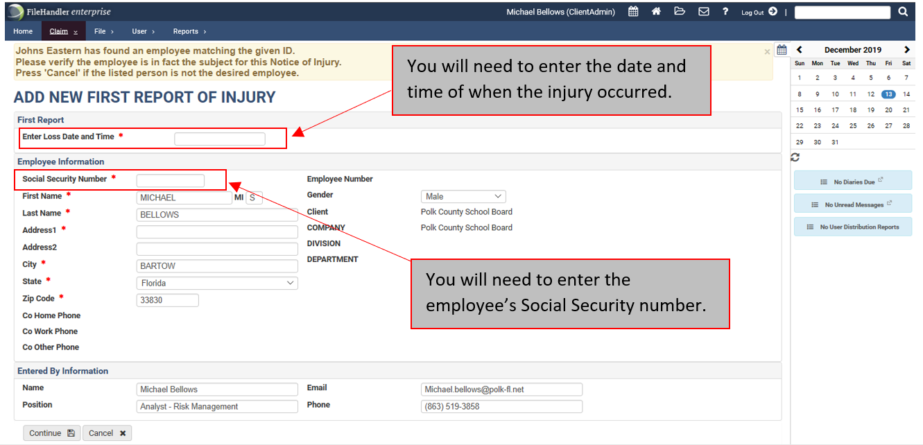
- After you enter the employee’s SAP number or Social Security number, then select “Search”. You will be taken to a new screen in which you will see the employee’s information. Verify that all the pre-populated information is correct and then enter in the date and time of the injury, and the employee’s Social Security number.
*If a match is found, you will see this screen. If the information is correct, click “Continue”. If the information is not correct, click “Cancel” and re-enter the SSN or Employee ID. If there is no record, then everything must be entered manually.

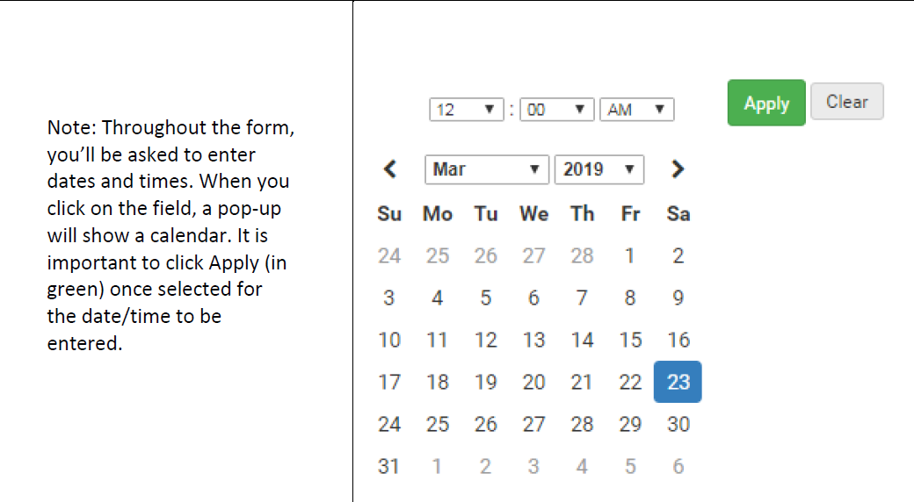

Throughout the form you’ll be asked to enter dates and times. When you click on the field, a pop-up will show a calendar. It is important to click “Apply” once selected for the date/time to be entered.

Step 1: Employee Summary
- This information should be pre-populated based on the information previously entered. If it does not pre-populate, you may need to enter the information in manually.

Step 2: Employee Detail
- You will be prompted to enter the injured employee’s first and last name, date and time of loss, and a description of the accident.
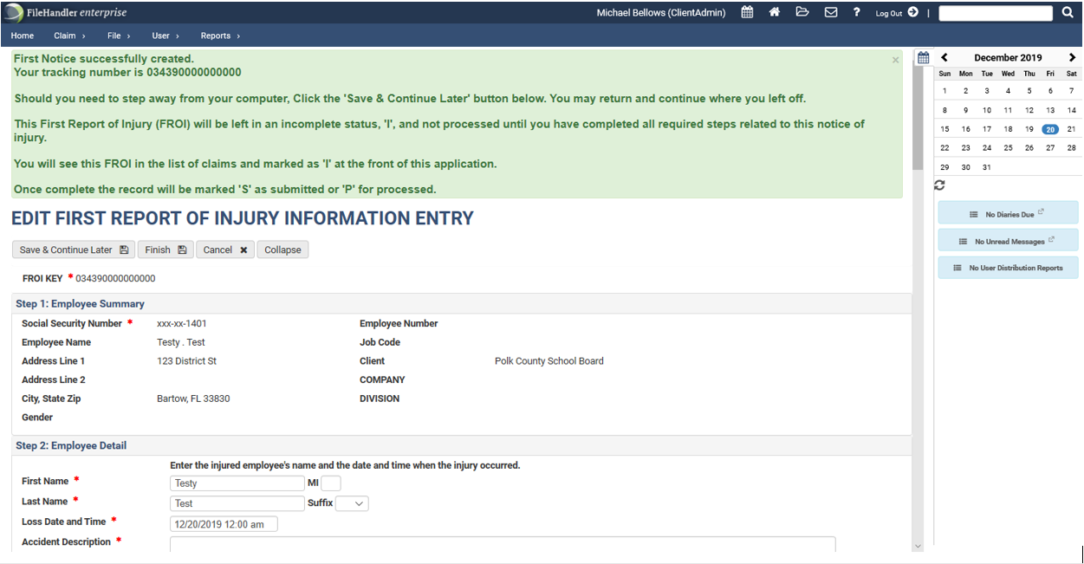
*It is imperative that you be as descriptive as possible when completing the Accident Description box. Include facts and details about the event like injuries (bruise, scrape, cut, burn, etc.), location of injuries including part of the body and side of the body (left pointer finger, right inside forearm, left outside shin, etc.)

Step 3: Employee Information
- Be sure to enter all information completely and accurately.

Step 4: Employee Contact Information (Please supply at least 1 phone number)
- Be sure to enter all information completely and accurately.

Step 5: Employee Job Detail
- Use the drop-down menus in the order that they appear to accurately document the employee’s details.

Step 6: Employees Salary Detail
- Be sure to enter all information completely and accurately.
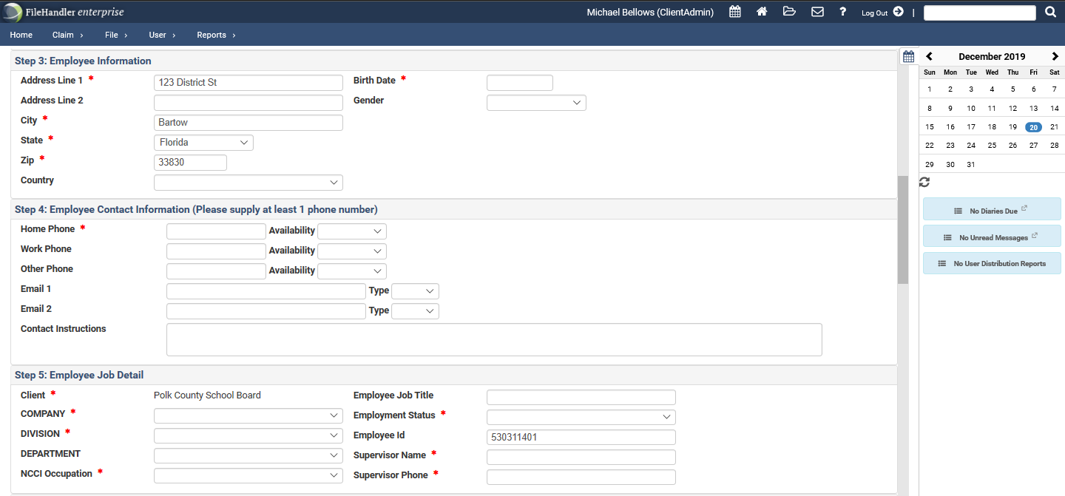

Step 7: Accident Detail
- Under the Report Only drop-down menu, select “Yes” if, and only if, the employee does not immediately seek, or plan on seeking, medical treatment for any injury sustained during the incident. If the employee DOES plan on seeking treatment at any point for an injury sustained during the incident, select “No”. *The employee should visit the PCPS Health and Wellness Clinic within 24 hours.
- Under the Loss Type use the drop-down menu to select the option that best applies to the injury/injuries sustained during this incident. Once a Loss Type has been selected, new drop-down menus will appear allowing you to further select a description.

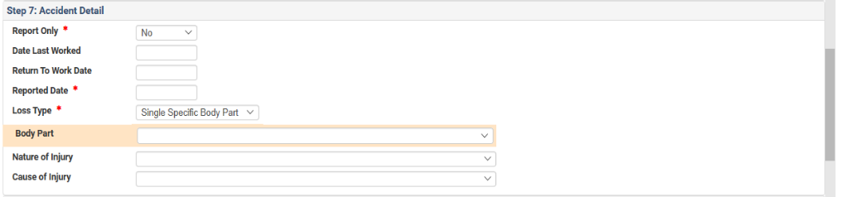
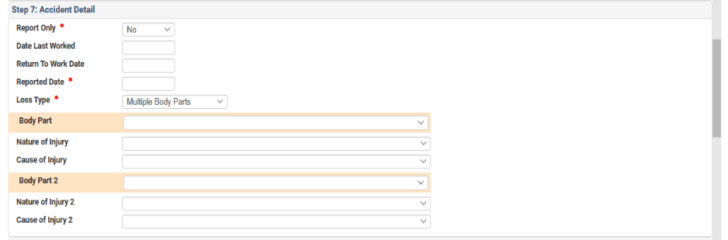
*Note that once the Loss Type has been selected, drop-downs will appear for you to select more specific aspects of the injury/injuries.

Step 7A: Accident Detail Continued
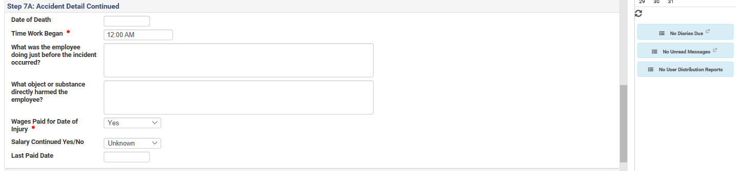
- Be sure to enter all information relevant to the accident’s detail. Remember to be as specific as possible!
Step 8: Place of Accident
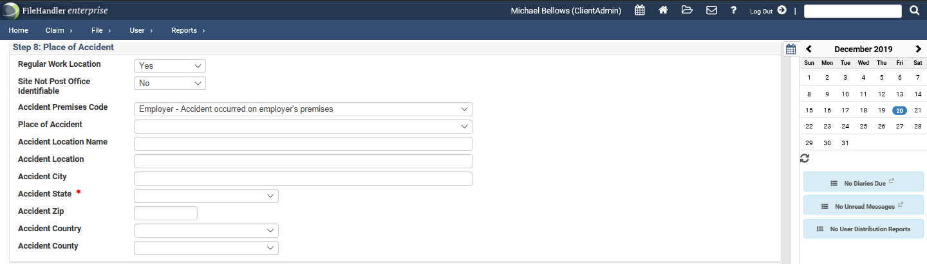
- Be sure to enter all appropriate information relevant to the location of the accident.

Step 8A: Physician Details
- All employees involved in a workers’ compensation accident should be directed to follow up with one of the Polk County School Board Health Centers immediately or within 24 hours. (Information for the health centers can be located on page 18 of this manual.)
- Through the Medical Provider drop-down, one of the two wellness clinics will be available to select.
- Under the Provider Authorized by Employer drop-down, you should select “Yes”.

*The emergency room is used to stabilize an injury (triage) only. Management of care and work restrictions will be directed by the PCSB Health Center.

Step 8B: Witnesses
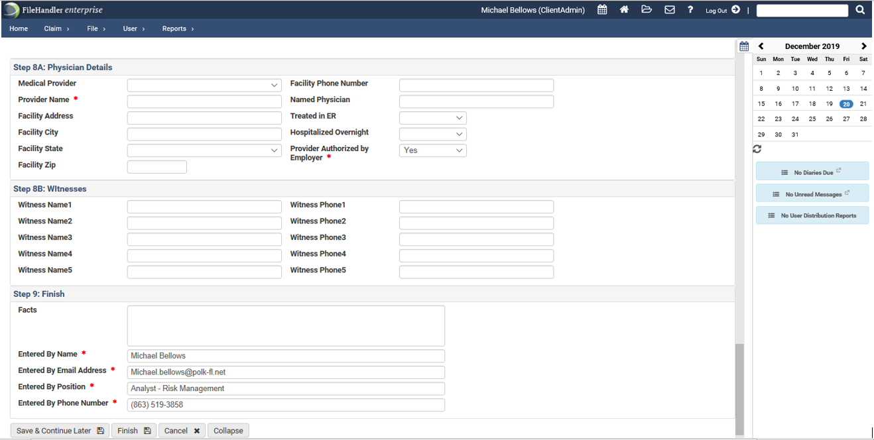
- Be sure to document any and all witnesses to the employee’s accident.
To finish the incident report, click the “Finish” button.
If at any time you need to save your incident report and continue it later, you can click this button.

*Upon completion of the report, you will be asked if you would like to print the report to keep for your own records.

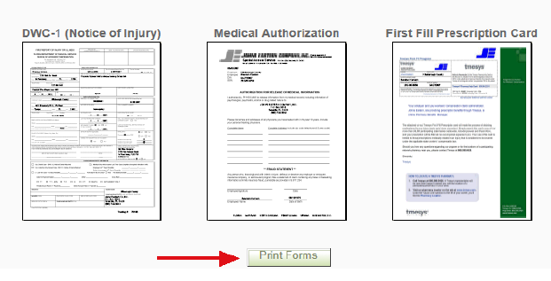

Section II: After Hours Reporting

- Report the injury/incident to your supervisor immediately.

- If medical treatment is sought outside of the PCPS Wellness Clinics, the employee must follow up with one of the clinics within 24 hours for management of care and work restrictions.

- Inform the location in which you are receiving treatment that the incident is a Workers’ Compensation accident. Emergency Rooms, Hospitals, and Urgent Care facilities are aware of the appropriate processes for workers’ compensation injuries. These facilities are only to be used to stabilize injury and provide urgent medical treatment.

- The employee’s supervisor has a duty to complete/file a notice of injury. They should work with the Risk Management Department and the claims administrator to complete a notice of injury within 24 hours.

- If restrictions or time off is recommended by an outside provider, it is imperative that such time off and/or restrictions are confirmed by PCPS Health Center providers prior to implementation.

- For injuries after 6 pm, employees will need to notify their supervisor immediately of any incident that may have occurred. Supervisors must ensure a First Report of Injury is entered into the Johns Eastern system as soon as possible to ensure appropriate processes are initiated immediately. The employee MUST follow up with a PCPS Health Center as soon as possible if treatment is sought anywhere regarding the incident.

REMEMBER: Just because the accident happened after hours does not mean it is going to be covered by Workers’ Compensation. If an injury happens, a claim MUST be entered into Johns Eastern. It is not the responsibility of the school or faculty to determine whether an accident is considered Workers’ Compensation or not; this is the role of the Risk Management Department and its’ claims administrators.

When in doubt…fill it out!

Section II: Pharmacy Information
Dear PCPS Injured Worker,
The District uses the vendor listed below to assist you in obtaining prescription drugs related to your workers’ compensation claim. This form enables you to fill your first prescription written by your authorized workers’ compensation physician for the medication related to your recent work injury. Simply present the form below to the pharmacy at the time your prescription is filled. This form guarantees that you will have no out-of-pocket expenses when you fill your first prescription.
You may use your local pharmacy to process your prescription(s) with a cost maximum of $150 per prescription and no more than a 14-day supply per prescription. Once your claim is reviewed, you will be sent a prescription card in the mail. If you do not receive the pharmacy card within a few days, call the vendor at the number listed below.
You may use your local pharmacy to process your prescription or call the toll-free customer service number or visit the website below to identify additional network pharmacies in your area.
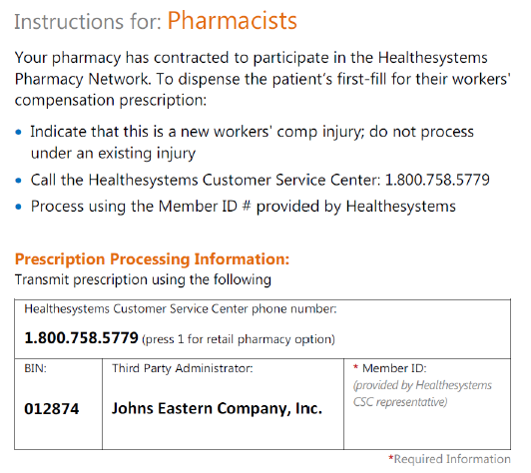

Remember: DO NOT use your Blue Cross Blue Shield Insurance.

Section II: Exposure to Bloodborne Pathogens
If you believe that you have been exposed to a bloodborne pathogen you should immediately:
- Wash the needlestick, cut, or wound with soap and water
- Flush splashes to the nose, mouth, or skin with water
- Irrigate eyes with clean water, saline, or sterile irrigates
No scientific evidence shows that using antiseptics or squeezing the wound will reduce the risk of transmission of a bloodborne pathogen. You should not use a caustic agent such as bleach to clean the wound.

After initial treatment of the exposure has been completed, report the exposure to the Risk Management Department. You will be instructed to enter a First Report of Injury or a Student or Visitor Accident Report into the Johns Eastern website. Risk Management will instruct the school or facility to ensure that the individual who experienced the exposure receives immediate treatment.

In the event of a true bloodborne pathogen exposure, the Polk County Public Schools Health Center will complete a panel of baseline labs (HIV, Hepatitis B, Hepatitis C), then after 6 weeks the clinic will draw another panel of labs (HIV and Hepatitis C), and again after 6 months (HIV and Hepatitis C).

Section II: Authorized Medical Care Facilities

Lakeland Health Center  3215 Winter Lake Road  Lakeland, FL 33803  (863) 419-3322 option 1 | Monday – Friday  8:00am – 6:00pm  Saturday 7:00am - Noon
Haines City Health Center  641 US Hwy 17-92 West  Haines City FL 33844  (863) 419-3322 option 2 | Monday – Friday  8:00am – 6:00pm  Saturday 7:00am - Noon

The Polk County Public Schools Health Center should always be used for the initial visit and further treatment. Employees should use authorized facilities only and the Emergency Room should only be used if it is a true emergency (i.e. broken bones, head injury, major blood loss). Visits to the Emergency Room are only approved for life threatening emergencies. If the Emergency Room is visited prior to the clinic, the injured employee must follow up with PCPS Health Center within 24 hours in order to obtain appropriate restrictions and instruction regarding workers’ compensation policies and procedures where applicable.

Should an employee receive restrictions or limitations through an outside provider, that employee must have those restrictions confirmed through the PCPS Health Centers, otherwise, he/she may be in jeopardy of forfeiting Workers’ Compensation benefits.

- Services provided by the PCPS Health Centers include tetanus shots/post-accident drug testing/sutures.

- Please note that the use of workers’ compensation leave requires approval by Risk Management.

Section III: Emergency Room Guidelines

When an employee is transported or seen at the ER, the employee must inform the Emergency Room that it is a workers’ compensation injury and the employee must follow-up with one of the PCPS Health Center within 24 hours.

When an employee is injured, the facility or department may think it best to send the employee to the Emergency Room. When warranted, this is not a problem; however, when it is not warranted, this costs the Polk County School Board a great deal of unnecessary expenditures.

Employees should be sent to the Emergency Room if one or more of the following criteria are met:
- Injury is serious enough to call 911
- Electric Shock
- Amputation
- Bone penetrating the skin
- Massive loss of blood
- Severe head trauma (i.e. loss of consciousness, unequal pupils, disorientation, etc.)
- Anaphylactic allergic reaction
- Heart attack, stroke, convulsions
- Severe burns
- Poison

Remind the worker that the Emergency Room (ER) is for emergencies only! When site personnel determine that emergency care is warranted for an injured employee, the employee must follow-up with a school board clinic within 24 hours of emergency treatment. Notify Maria Lugo (863-519-3858 ext:473) or Michael Bellows (863-519-3858 ext:582) in the Risk Management & Benefits department immediately when any employee is sent to an Emergency Room.

Section III: Employees with Restrictions (Light Duty)

Instruct the injured worker to return to the work location with all paperwork from the authorized workers’ compensation provider including the DWC-25 / “Work Status”.

If the medical provider recommends an employee for modified duty with restrictions, the school and /or department shall accommodate their employees who are injured on the job by providing work assignments in accordance with any authorized Workers’ Compensation doctor restrictions. In most cases, the employee can self-regulate; adjust their work to prevent further injury according to specified restrictions (Section 23 of the DWC-25). If the employee feels too sick or injured to return to work after the doctor releases them to modified duty, the lost time should be marked as sick, or without pay. All concerns should be discussed with Risk Management.

School responsibilities for light duty contact:
- Sign Temporary Light Duty Form. This form will be sent electronically from the Risk Management Department once we receive the injured employees' restrictions from one of our PCPS Health Center.
- Explain to the injured employee the light duty assignment (cannot exceed doctor’s restrictions), location, and hours. Every effort must be made to secure light duty work in their current work locations.
- Communicate with timekeeper regarding workers’ compensation time. Time keepers will use the code “OI40 AB Injury/Illness Duty” or “OI89 AB Workers Comp Absence”. IF THERE IS ANY CONFUSION ABOUT HOW TO CODE AN EMPLOYEE’S TIME IN REGARD TO WORKERS’ COMPENSATION, CONTACT RISK MANAGEMENT.

Possible Light Duty assignments as determined through Risk Management are as follows:
- Hall duty, assist monitoring student conduct
- Shredding paper and/or making copies
- Facility security using a walkie-talkie to report issues
- Video camera monitor
- Cafeteria monitor
- Escorting students/guests on campus when they arrive late or leave early for appointments
- Assist the front office/guidance office
- Mail duties, making phone calls, and distributing flyers
- Inspect for safety hazards, document hazards, and complete hazard work orders to the school safety committee

For custodial or food service employees, coordinate modified duty restrictions with the lead custodian or food service manager to keep all levels of management informed of workers’ restrictions.

If the medical provider recommends an employee for modified duty, the injured worker must return to their regular work location. The supervisor must allow the injured worker to return to work if applicable and ensure that the employee does not exceed the doctor’s limitations.

Section III: Workers’ Compensation Leave

When an employee is placed off work by an authorized workers’ compensation (WC) provider, please follow these guidelines for payroll reporting and leaves:

- Authorized WC leaves should be coded “OI40 – AB Injury/Illness Duty (ILOD)”
  - Typically, a WC incident is allotted 10 AB Injury/Illness Duty (ILOD) days. However, no more than 10 days are allowed per school year regardless of the number of accidents.
  - If a holiday falls into the time period of the “AB Injury/Illness Duty (ILOD)” is being recorded, please leave the code “REG” on the payroll for holidays and return with the AB Injury/Illness Duty (ILOD) code after the holiday break.
- If the employee has exhausted all 10 “AB Injury/Illness Duty (ILOD)” days, the “OI89 – AB Workers Comp Absence” code should be used. (Note: Johns Eastern the Workers’ Compensation Administrator will begin paying if absence is authorized)

If the employee is in an unpaid status or “leave” for the majority of their duty days in any given month, health benefits may be in jeopardy. The employee should inquire if they qualify for a FMLA leave.

Payroll:
On the day of injury, injured employee’s payroll should be mark as 0I40 “AB Injury/Illness Duty Pay”.

If the Workers’ Compensation provider indicates that the employee has no restriction or that the employee can continue full duty work, then the time will continue to be coded as normal. If the employee does not report to work at their regularly scheduled time despite receiving full duty clearance from the PCPS Health and Wellness Center providers, that employee will be subject to disciplinary action and will continue to use their personal/sick time.

If the Workers’ Compensation providers indicates an employee must be on a “no work” status, the code 0I40 “AB Injury/Illness Duty Pay” will be used (for up to 10 days). (See sample form DWC-25 in Section 6) Risk Management will remain in contact with the school/department in situations where the employee is on a “no work” status.

After the employee has used up the 10 days of In-Line of Duty time and a workers’ compensation doctor still has them on no work status, please notify Risk Management, so that we may contact Johns Eastern.

When an employee’s time is coded using 0I89 (AB Workers Comp absence) an approved workers’ compensation leave, Johns Eastern will pay 66 $\frac{2}{3}$% of the average monthly wage. Please make sure that the first 10 days of Inline of Duty have been exhausted before using this code.

How to read a DWC- 25 (See sample in Section 5)
# 21 - Full Duty, no functional limitations = REG (Regular Earnings)
# 22 - No Work Status= OI40-AB Injury/Illness Duty Pay or OI89 AB Workers Comp absence

Section III: Doctors Appointment Guidelines

When an employee is required to attend appointments related to a workers’ compensation injury, the employee should avoid scheduling appointments during working hours.

The only exception to the above is if the doctor requires a diagnostic test that must be scheduled immediately and the only appointment available is during work hours.

The employee should schedule the appointment which will cause the least loss of time (i.e. late afternoon or early morning). In this case, the time reporting code for In-Line of Duty is “OI40-AB Injury/Illness Duty”.

It is important to remember that once the employee uses up the designated 10 days of paid workers’ compensation leave, no exceptions will be made if any further necessity of time for appointments, procedures, or surgeries arises. If the employee requires time off for said appointments, the code 0I89 should be used.

Substitutes, volunteers, and temporary employees are not eligible for ILOD pay.

Section IV: Reporting Volunteer/Temporary Employee Injuries

School Nutrition/Support Services/Custodial Substitutes (employed by PCPS):
Substitutes have an SAP number; therefore, the procedures for reporting an injury are the same as a regular employee (refer to the instructions for entering a claim through the Johns Eastern reporting website).

Substitutes do not receive “In Line of Duty” days. If they are given a “no work status” they may be paid by workers’ compensation for lost wages based on their average monthly wage if accommodations cannot be met.

Substitute teachers (employed by Kelly Services): Substitute teachers need to report the incident to Kelly Services as they are not covered under the Polk County School Board’s workers’ compensation program. If a substitute teacher is involved in an accident or incident on a campus or in a facility, then a Student or Visitor Accident Report must be completed. Although long-term substitute teachers assigned to a specific school do have an SAP number, they still need to report an incident to Kelly Services.

Interns:
Paid interns have an SAP number; therefore, the procedure for reporting an injury is the same as a regular employee (refer to the instructions for entering a claim into the Johns Eastern reporting website). Interns do not receive “In-Line of Duty” days. If they are placed out of work, they may be paid by workers’ compensation for lost wages based on their average monthly wage. Typically, interns are not offered light duty.

Unpaid interns will not qualify for workers’ compensation through the Polk County School Board. If an unpaid intern is involved in an accident or experiences an illness on a campus or in a facility, then a Student or Visitor Accident Report will need to be completed.

Volunteers:
Volunteers do not have an SAP number so they will not fall under the Polk County School Boards workers’ compensation policy. If a volunteer is involved in an accident or incident on a campus or in a facility, then a Student or Visitor Accident Report will need to be completed.

Section V: Resources/Forms

DWC-25 Work Status Form
Injured employees must provide a copy of the Florida Workers Compensation Uniform Medical Treatment/Status Report Form (DWC-25) after each medical appointment to their supervisor/school/department secretary. This form is commonly referred to as the “Work Status Form.”
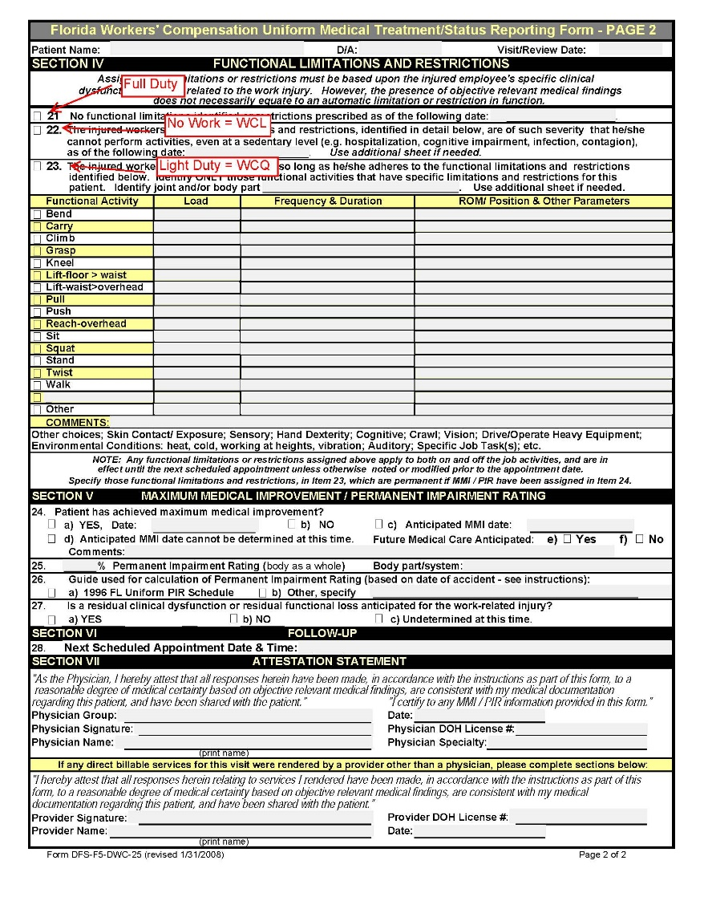
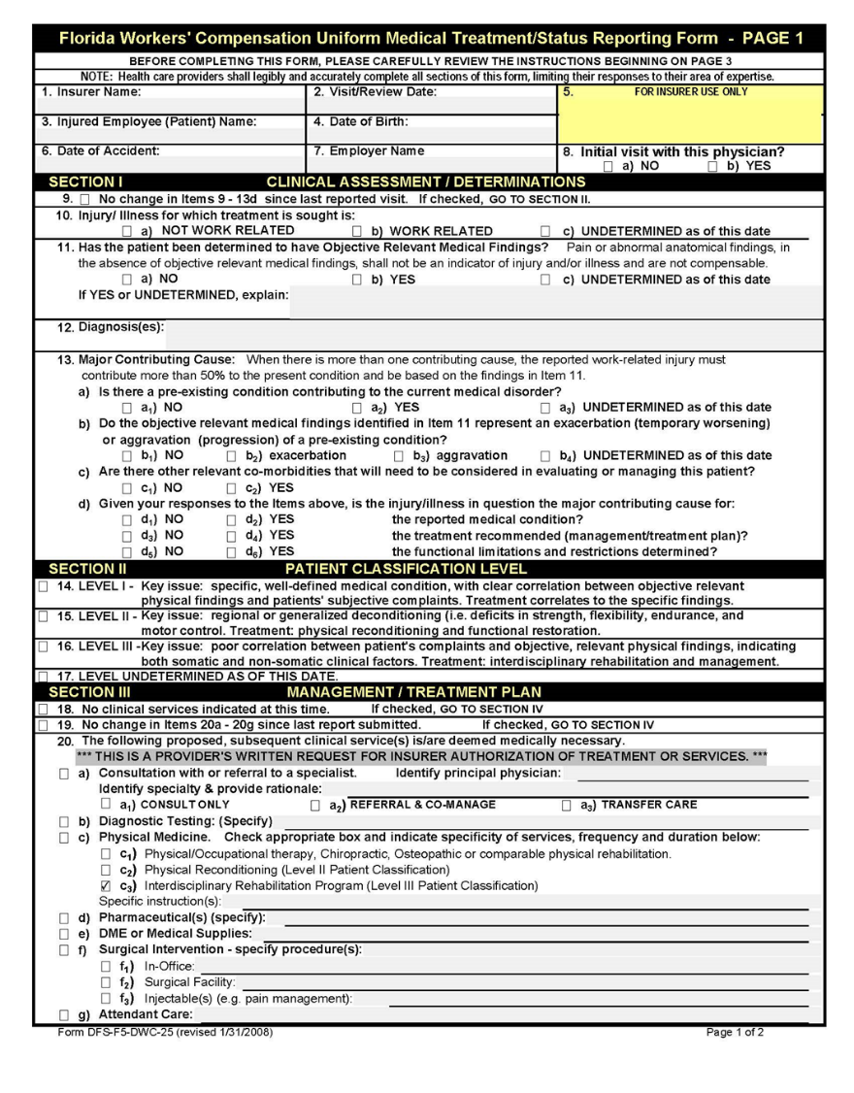

Section V: Frequently Asked Questions
If I do not think the injury is Workers’ Compensation related, do I still need to put in a claim if an injury is reported?
Yes. Any accident/injury should be entered through Johns Eastern. It is not the responsibility of the school to determine whether an accident is Workers’ Compensation related. That is the responsibility of the claims’ administrators and the Risk Management Department.
What code do I use to cover doctor’s appointment and time off?
0I40 “AB Injury/Illness Duty (ILOD)” or “OI89”. If employee does not return to work after the appointment, they will have to use own personal time unless the appointment is later in the day.
If an employee has surgery and is off work what code do I enter for their absence?
Time must be coded 0I40 for the first 10 days, then 0I89 for days after.
Will Johns Eastern pay for time off?
If employee is off work (after the 10 paid days allowed by the PCSB) Johns Eastern will pay 66 $\frac{2}{3}$% of the employee’s monthly salary and the employee will receive a paper check. They have the option of using their own sick pay to cover the remaining percentage.
What is considered a workers’ compensation claim?
Any incident that happens on a Polk County School Board site that is within the claimant’s scope of job duties (including slips and falls coming and leaving work).
How late can a claim be reported?
The employee has 30 days to report an injury. Every claim will be investigated to determine if it is compensable.
Do I have to send back Incident Investigation Forms?
Yes! It is mandatory to complete and send Incident Investigation Forms back to the Risk Management Department. The school is responsible for initiating any correctional actions necessary to prevent any further similar incidents.
Does the Temporary Light Duty form need to be signed by both supervisor/principal and employee?
Yes! It must be signed and must include what the accommodational job duties will be.
If I suspect a false claim, what do I do?
Please email any information you have been given or witnessed. Everything must be in writing for tracking purposes.

Section V: Best Practices for Schools/Site Administration:
- Cover injury-reporting procedures in school/site-wide staff meetings.

- Emphasize the use of PCPS Health Centers and post it in several conspicuous places so all employees have access.

- A minimum of two people (usually the school secretary and one additional designee) should have access and ability to enter a “First Report of Injury” in Johns Eastern.

- Employees are to immediately report any worker-related accident or injury to their supervisor/manager/school/department secretary. All injuries must be reported even if no treatment is sought.

- Do not file a First Report of Injury (FROI) for single insect bites (bugs, mosquitos, and spiders), bee stings, and/or lice.

- Provide the employee with a copy of the “Employee Guide” for the workers’ compensation program. Copies can be found on The HUB or requested through the Risk Management Department.

- Remind employees not to use their Blue Cross and Blue Shield Insurance for any services related to Workers’ Compensation Injury/Illness.

