Program Overview

Who to contact with questions?

What information is needed to complete the report in Johns Eastern?

What should be done once the information is collected?

What should I do if Medical Assistance was required?

What should I do if 911 was called?

It is our mission to provide the highest quality services to the employees, students, and visitors of the Polk County Public Schools (PCPS) as efficiently and effectively as possible. Therefore, we are committed to providing the necessary tools for employees to accurately and efficiently report accidents and illnesses.

Michael Bellows, Risk Management – Analyst (863) 519-3858 ext.582 michael.bellows@polk-fl.net
- Student/ Visitor demographic information
- A detailed description of what took place, including where the accident took place and who may have witnessed the accident;
- Always include the injured body part(s);
- If medical treatment is sought, you will need to complete the appropriate sections.
- If the report is for an illness you will need to know (1.) if the student went to the school clinic, (2.) were they transported by someone, and (3.) if there was direct blood contact.

IMPORTANT NOTE: School Insurance of Florida will NOT process a claim if the student did not receive medical treatment outside of the school. In addition, School Insurance of Florida does not pay out for incidents involving fights in which the student was actively participating; claims may only be processed if the student does not fight back.

Enter the information into Johns Eastern website:

https://johnseasternenterprise.jw-filehandler.com/Home.aspx
- The user ID is PCS and then a five digit SAP number. If your SAP number is less than five digits add zeros to the front of the SAP number to have five numbers totaled. For example, if you SAP number is 614 your user id would be PCS00614. The initial password when you log in for the first time is Jeco1234 (‘J’ is capital).

A report must be entered into the Johns Eastern system. The report must be printed and emailed promptly to:
- School Insurance of Florida: JimG@LESmith.net

If 911 was called even if the student was not transported email the following:

- Jamie Kress: jamie.kress@polk-fl.net
- Juliette Morse: Juliette.morse@polk-fl.net
- Evelyn “Kay” Henry: evelyn.henry@polk-fl.net
- Kimberly Taylor: Kimberly.taylor@polk-fl.net
- Risk Management: studentaccident.PCSB@polk-fl.net

What type of accidents should be entered into Johns Eastern?

Should I keep an electronic copy of the form?

Important information regarding School Insurance of Florida

Student Accident Report NOT required:
- Minor cuts and scrapes where nothing more than a cleaning and a bandage is needed
- Minor bumps and bruises other than head-related injuries
- Particles in the eyes which were removed with no complications

Student Accidents Report IS required:
- Any head-related injury
- For all 911 calls transported or not
- Accidents other than those listed above
- When a student is detained in the school clinic for observation
- A suspected sprain or fracture
- Minor injuries sustained in an athletic competition

Best practice would be to create a file folder on your computer to store an electronic copy of the Johns Eastern report. It is not required to save a copy of the report. The Johns Eastern system will maintain the report, and it can be looked up at a future date.

Please visit the School Insurance of Florida website for important information on how the supplemental student accident insurance policy that Polk County Public Schools (PCPS) has purchased works as well as optional Extended 24 Hour Coverage Accident Insurance Plan.

https://schoolinsuranceofflorida.com

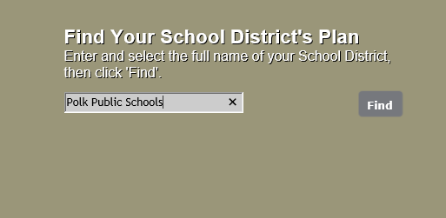
Click ‘find’ to research policy information for PCPS
Enter Polk Public Schools

