Salary Reduction Agreement Processing Service

Employee Online SRA Tutorial

TSA Consulting Group, Inc.
Compliance & Administration Service Provider
Client Services
73 Eglin Parkway NE • Fort Walton Beach, FL 32548
888.796.3786 Option 5 • sraprocessing@tsacg.com

Dear Employee,

Polk County Public Schools is pleased to announce that enhancements have been made to the 403(b) Salary Reduction and 457(b) Participant Agreement (SRA) process effective 01-01-2021. New election requests will be submitted through an online system. This system is provided by our 403(b) and 457(b) Plan Administrator, TSA Consulting Group, Inc. (TSACG). The online process eliminates the need for paper SRAs and allows 24-hour access for employees. All approved representatives of the District’s authorized investment provider companies will be able to assist employees with this online process.
There are many benefits to the new enrollment process:

There are many benefits to the new SRA process:

- Employees simply visit https://sra.tsacg.com to access the online system.
- The system can be accessed 24 hours a day, 7 days a week.
- Employees can start, change, or stop a 403(b) and/or 457(b) SRA at their convenience.
- Employees receive immediate online confirmation that their request has been submitted.
- Authorized Investment Provider Agents/Representatives can assist employees.
- A list of authorized Investment Providers is available at www.tsacg.com.

Employees should utilize the below instructions to successfully utilize the online Salary Reduction Agreement process:

1. Before completing the online Salary Reduction Agreement process, you MUST have an account established with the authorized Investment Provider of your choice.

2. Navigate to the secure website https://sra.tsacg.com.

3. Note that the SRA information entered via the online system will supersede and replace all prior 403(b) and/or 457(b) elections including the amounts, investment providers, and effective dates. Any election(s) you want to continue must be reflected or the election will be stopped.

4. Employee Certification – You must confirm that you are eligible to participate in your employer’s plan. You will also be confirming that you have established your account under your employer’s plan with one of the Authorized Investment Providers. Click “Confirm” and then click
“Submit”. 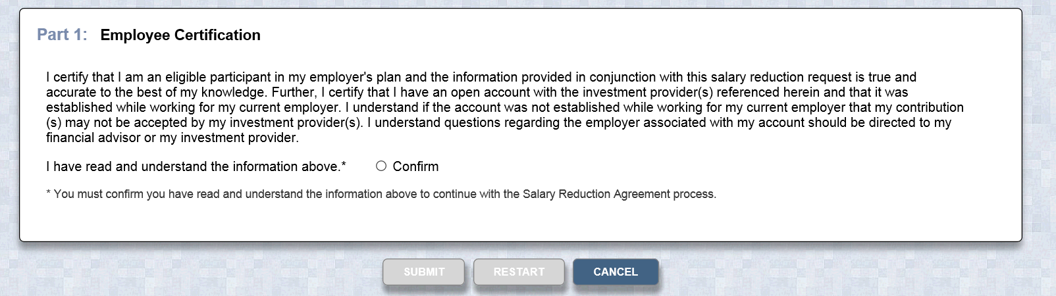

Employer and Participant Information – If you have previously entered SRA information or TSACG has your demographic information archived in their system, most of your personal information will pre-populate. If your information is not currently in TSACG’s system, you will be able to add your record. Depending on the information displayed, be prepared to enter the following information:

- Employer’s State
- Employer’s Name
- Employee’s Social Security Number
- Employee’s Date of Birth
- Employee’s Name, Address, and Telephone Number
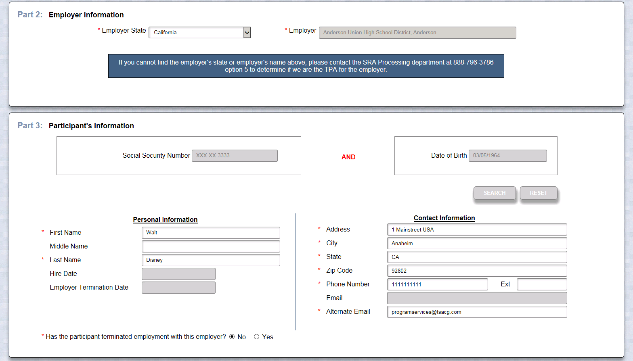

5. Salary Reduction Agreement Information – You have the ability to start, change, or stop contributions. If you want to maintain an existing contribution(s), you will need to enter the information for that contribution in addition to any other changes you are making. Be prepared to enter the following information:

- Effective Date of the contribution(s)
- The total dollar amount per pay period for all contributions
- The investment provider(s) to whom you would like to contribute
- The Plan type
- The amount of a previous contribution, if any – not required to submit
  - This information can be found on your pay check stub, you can also call TSA Consulting Group (contact information provided at the bottom of this communication), or by checking with your investment provider directly
- The new amount of your contribution
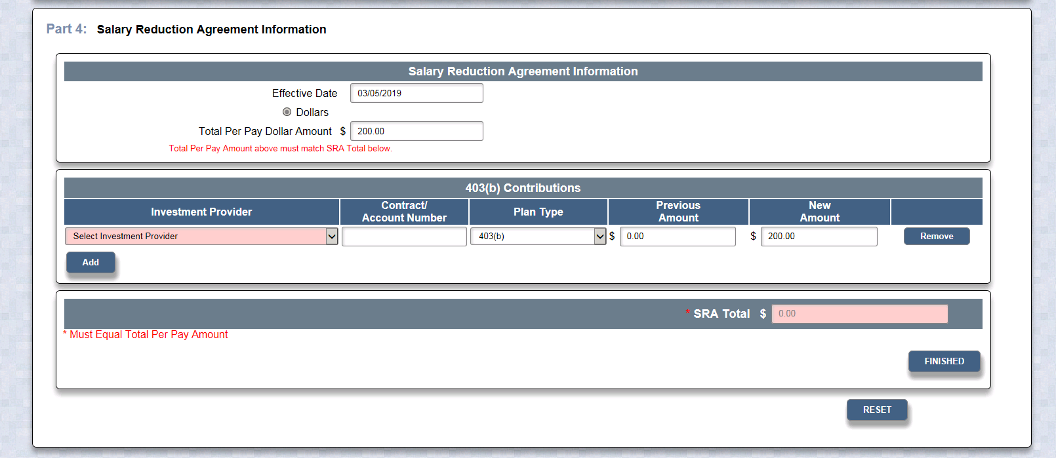

6. Salary Reduction Agreement Terms and Disclosures – Once you have clicked Finished, you will be asked to read and confirm that you have read the SRA terms. You will also be asked to acknowledge the SRA disclosures.

7. Submitting your SRA – After completing the terms and disclosures sections, you will be asked to confirm that you are not a robot, and then you can submit your SRA. TSACG will forward your contribution information to us, and you can print a copy of the SRA for your records. Providing your account(s) is established with your investment provider, no further action is required.

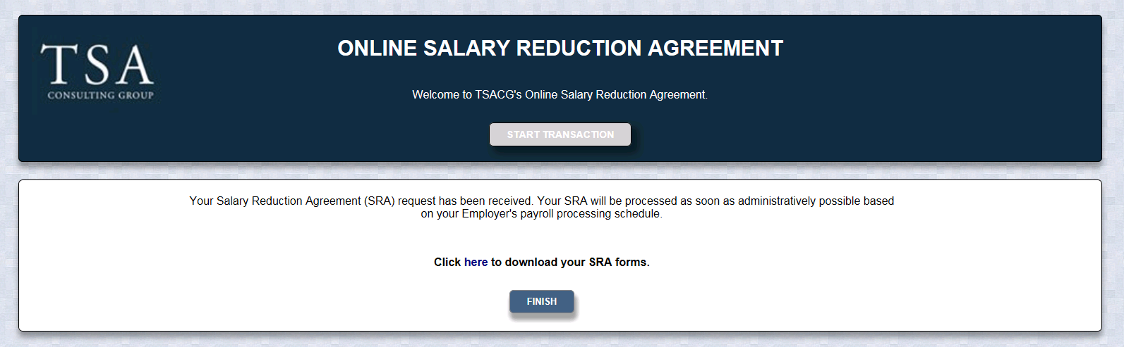
Should you have any questions regarding the process, please contact TSACG’s SRA Department at 888.796.3786, option 5.

